Method of Extrusion Granulation of Aggregates for the Preparation of Filling Mixtures
Zagorodnyuk L.H.^{1[0000-0002-8441-6999]}, Ryzhikh V.D.^{1[0000-0002-5159-4967]},
Makhortov D.S.^{1[0000-0003-4850-1173]}, and Sumskoy D.A.^{1[0000-0002-0001-6139]}
¹Belgorod State Technological University Named After V.G. Shukhov,
Belgorod, Russia
LHZ47@mail.ru
Abstract. Underground mining technology is one of the most promising areas of mining. Optimization and cheapening of the production process of mining enterprises are important tasks for the scientific society. The use of technogenic waste, as well as unclaimed and substandard raw materials for the production of filling mixtures in all areas of the globe is an urgent problem of ecology and materials science. Research is being conducted in the direction of increasing energy efficiency and reducing the cost of technological production of filling mixtures for laying out the developed space. A number of works were carried out to obtain composite binders with different granulometric characteristics. As part of the research, extrusion granulation works were carried out on the basis of composite binders and quartz sands of different fractional compositions (≤0.16 mm, ≤0.315 mm, ≤0.63 mm). 36 types of granulated aggregates with different component compositions were obtained. The partial replacement of fine quartz sands in the composition of the filling mixture with different types of granular aggregates was carried out. As a result, the most promising component compositions were identified and the economic and environmental efficiency of using certain granular aggregates as a large aggregate in filling complexes with a cement binder was proved.
Keywords: Filling Mixtures, Portland cement, Composite Binders, Granulation, Granulated Aggregates, Quartz Sand.
1 Introduction
The underground mining industry is one of the most promising industries that needs active modernization and scientific and technical research in order to improve the technical and economic indicators of the production process. The technological growth and development of the mining industry, today, in the territory of the Russian Federation (RF) is at the stage of stagnation.
Currently, scientists are developing and optimizing the component compositions of filling mixtures that contribute to saving material, energy and financial resources [1-4]. In order to save financial resources, various mining enterprises using the underground mining system use local and technogenic raw materials in the production of filling mixtures. For the use of local cheap building materials and industrial waste, in most cases, individual development of composite compositions of filling mixtures and the arrangement or re-equipment of the production line is necessary, which requires significant financial investments.
A systematic urgent problem in the mines of the Russian Federation, using the technology of hardening laying, is the overspending of expensive Portland cement. Often, this overspend is due to the use of fine aggregates (fine quartz sands and industrial waste) in the component composition of filling mixtures, which reduce the physical and mechanical characteristics, and solidified filling masses.
Practice shows that the lack of large and small natural aggregates in different territorial areas slows down the development of the construction segment [5, 6].
Today, mining companies practically do not use inert fine aggregates in the composite compositions of filling mixtures. It should be noted that the use of quartz sand fractions less than 1 mm in concrete and filling mixtures is not regulated for the production of load-bearing building structures, as a result of which their storage reserves increase. Technological processes of agglomeration will help to get rid of substandard stocks of fine aggregates.
The use of technogenic waste in composite compositions of solutions and filling mixtures is an event aimed at creating a system of waste-free production with a consistent reduction of the negative impact of dumps of substandard raw materials on the ecological situation of the globe. Currently, there are a number of scientific studies [7-9] related to the granulation of technogenic waste and fine raw materials. It is noteworthy that to create cost-effective composite compositions of granular aggregates (GA), it is necessary to select the appropriate composite binders [10, 11].
The creation of effective composite filling mixtures with stable technological and physical-mechanical characteristics for the laying of the developed space is an important task for mining enterprises.
The problem of using unclaimed and substandard raw materials to create a hardening filling mass, with the possibility of implementation throughout the territory of the Russian Federation, while ensuring environmental protection measures is relevant.
2 Methods and Materials
The used raw materials are Portland cement (PC 500-D0-N), quartz sand (dispersion ≤0.63 mm ≤0.315 mm ≤0.16 mm).
Sifting of sand is carried out using standard laboratory sieves. Grinding of binders is carried out in a vortex jet mill VJM-01 [10]. Particle size distribution studies are being carried out on a laser analyzer FRITSCH Analysette 22 NanoTec. Quartz sand granulation is carried out in a portable Gemlux screw unit with a power of 3 kW. Physical and mechanical tests of cube samples are carried out according to Russian National Standard 10180-2012 on a hydraulic press PGM-50MG4.
The method of obtaining filling mixtures includes several stages:
- Preparation of raw materials (sieving of quartz sand, grinding of composite binders in VJM-01). Before grinding, 10, 20, 30% of quartz sand was added to the PC 500-D0-N to obtain three types of composite binders. The symbol and decoding of compositional binder formulas are presented in Table 1.
Table 1. Component composition of composite binders obtained in VJM-01.
Component composition of binder | Code (designation)
PC 500-D0-N | PC
PC 500-D0-N – 90% + quartz sand – 10% | Cb-1
PC 500-D0-N – 80% + quartz sand – 20% | Cb-2
PC 500-D0-N – 70% + quartz sand – 30% | Cb-3
- Extrusion granulation of quartz sands of different dispersion in the Gemlux screw unit. GA formulas are presented in Table 2. In the mixed mixture, according to the required formula, water is added. At the same time, the water-binding ratio in component compositions with 5% of the composite binder is – 3; with 10 % – 1.8; with 15 % – 1.4. The technological process of granulation is carried out by extrusion molding with pre-pressing of the water-saturated material in the working chamber of the Gemlux screw unit. The resulting GA gain strength for 28 days in air-wet conditions.
Table 2. Granular aggregate formulas.
Quartz sand fraction, mm | Type of binder
 | Cb-1 | Cb-2 | Cb-3 | PC
0.16 | 0.16+5% Cb-1  0.16+10% Cb-1  0.16+15% Cb-1 | 0.16+5% Cb-2  0.16+10% Cb-2  0.16+15% Cb-2 | 0.16+5% Cb-3  0.16+10% Cb-3  0.16+15% Cb-3 | 0.16+5%PC  0.16+10% PC  0.16+15%PC
0.315 | 0.315+5% Cb-1  0.315+10% Cb-1  0.315+15% Cb-1 | 0.315+5% Cb-2  0.315+10% Cb-2  0.315+15% Cb-2 | 0.315+5% Cb-3  0.315+10% Cb-3  0.315+15% Cb-3 | 0.315+5% PC  0.315+10% PC  0.315+15% PC
0.63 | 0.63+5% Cb-1  0.63+10% Cb-1  0.63+15% Cb-1 | 0.63+5% Cb-2  0.63+10% Cb-2  0.63+15% Cb-2 | 0.63+5% Cb-3  0.63+10% Cb-3  0.63+15% Cb-3 | 0.63+5% PC  0.63+10% PC  0.63+15% PC
- Mixing the components, forming the filling mixture and forming the sample cubes (3×3×3 cm). The composite composition and the percentage of components in the compositions of the filling mixtures are presented in Table 3. After the strength set, physical and mechanical tests of the cube samples are performed on the PGM-50MG4 hydraulic press for 28 days.
- Theoretical analysis of the results obtained and formulation of conclusions about the most effective form of GA for its use in the compositions of filling mixtures.
Table 3. Component composition of filling mixtures.
Type of filling mixture | Mass percent, %
 | PC | Quartz sand  (fraction ≤0.315mm) | Granular aggregate | Water
without granular aggregates | 30-35 | 30-35 | - | 30-40
with granular aggregates | 20-25 | 10-20 | 40 | 20-25
3 Results and Discussion
As a result of grinding in VJM-01, 3 types of composite binders were obtained, the granulometric characteristics of which are shown in Figure 1.
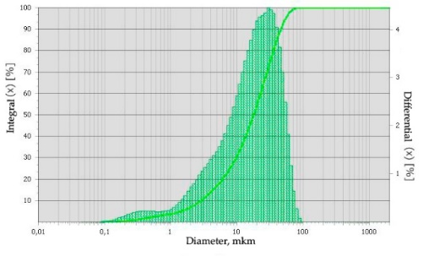  (a) | 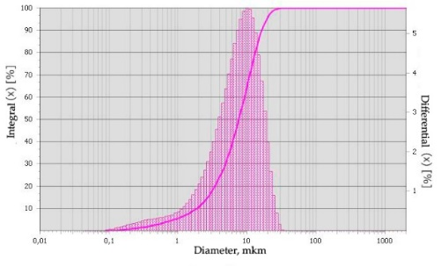  (b)
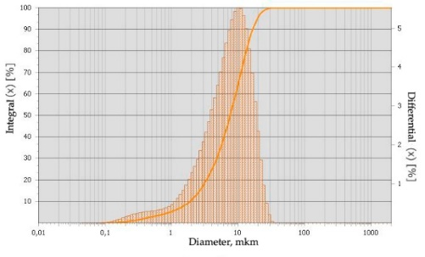  (c) | 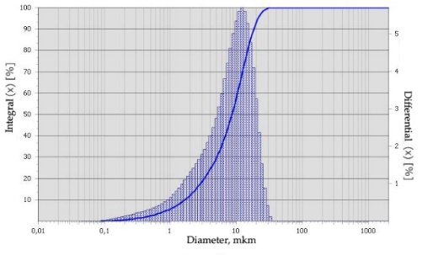  (d)
Fig. 1. Granulometric compositions of binders: PC (a), Cb-1 (b), Cb-2 (c), Cb-3 (d).
Analysis of granulometric curves of binders shows that after grinding in VJM-01 composite binders have increased dispersion characteristics than the original Portland cement PC 500-D0-N. According to the formula (Table 2), 36 types of GA of different density and porosity were produced by the extrusion method. The general view of the GA is shown in Figure 2. Granulation is performed using three types of quartz sands of different dispersion. It is noted that with different dispersion of sand and the percentage of binder in the composition of GA, the physical and mechanical characteristics of the filling mixture will differ. Therefore, it is necessary and sufficient to identify the most rational composite compositions of granular aggregates for the purpose of their further refinement.
After the molding processes (according to the formulas specified in Table 3) and the strength of the samples-cubes 3×3×3 cm for 28 days, the proposed method provides for testing the compressive strength of the samples on a hydraulic press PGM-50MG4. As a result of testing the cube samples, the following values are obtained, presented in Table 4.

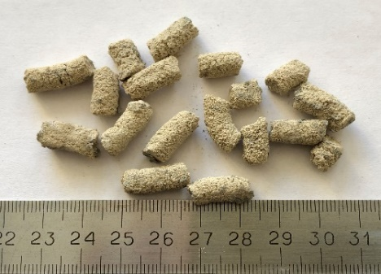  (a) | 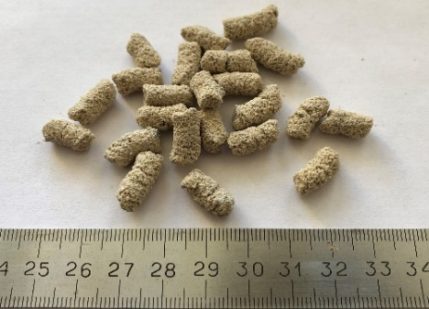  (b)
Fig. 2. Type of granular aggregates with linear dimensional units (millimeter) based on quartz sand fractions ≤0.16 mm (a), ≤0.315 mm (b).
The results of strength tests of cube samples indicate a positive effect of GA in the composition of the filling mixture. It is noted that the compressive strength of the samples-cubes with GA based on ground composite binders is higher than that of the samples-cubes with GA based on Portland cement. The interpretation of this fact is that the composite binder is characterized by high fineness of grinding, increased specific surface area and increased hydration activity. The rise of strength properties of samples-cubes with increasing the content of fractions of quartz sand in the GA from ≤0.16 mm to ≤0.63 mm and then adding a binder in GA from 5 to 15 % is noted. It is noteworthy that the change in the strength characteristics of samples-cubes when replacing GA with different composite binders (from Cb-1 to Cb-3) in the composition of the filling mixture does not occur in a linear relationship. This phenomenon is explained by an increase in the percentage of quartz sand in the GA, as well as a decrease in the hydration activity of the binder Cb-3. The insertion of quartz sand more than 20 % in composite binders for granulation of aggregates is impractical.
Table 4. Physical and mechanical characteristics of samples-cubes from the filling mixture under compression.
No. of composition | Code of sample-cube | Strength of samples-cubes, R_{compr}, MPa
 |  | №1 | №2 | №3
 | Without granular aggregates
1 | PC | 5.54 | 6.1 | 6.2
 | With granular aggregates
2 | 0.16+5%Cb-1 | 2.84 | 2.65 | 3.01
3 | 0.16+10% Cb-1 | 3.54 | 3.32 | 3.63
4 | 0.16+15% Cb-1 | 4.76 | 4.32 | 4.88
5 | 0.315+5% Cb-1 | 3.92 | 4.21 | 4.32
6 | 0.315+10% Cb-1 | 4.64 | 5.21 | 5.04
7 | 0.315+15% Cb-1 | 4.36 | 4.53 | 4.55
8 | 0.63+5% Cb-1 | 3.92 | 3.86 | 3.69
9 | 0.63+10% Cb-1 | 5.32 | 4.92 | 5.41
10 | 0.63+15% Cb-1 | 4.89 | 4.98 | 5.05
11 | 0.16+5% Cb-2 | 3.18 | 3.01 | 2.94
12 | 0.16+10% Cb-2 | 3.43 | 3.84 | 3.32
13 | 0.16+15% Cb-2 | 4.32 | 4.18 | 4.25
14 | 0.315+5% Cb-2 | 3.43 | 3.51 | 3.39
15 | 0.315+10% Cb-2 | 3.85 | 3.79 | 3.94
16 | 0.315+15% Cb-2 | 4.21 | 4.23 | 4.65
17 | 0.63+5% Cb-2 | 4.35 | 4.62 | 4.44
18 | 0.63+10% Cb-2 | 5.96 | 6.43 | 6.39
19 | 0.63+15% Cb-2 | 6.72 | 6.71 | 6.82
20 | 0.16+5% Cb-3 | 3.29 | 3.11 | 3.51
21 | 0.16+10% Cb-3 | 3.45 | 3.08 | 3.39
22 | 0.16+15% Cb-3 | 4.23 | 4.25 | 3.96
23 | 0.315+5% Cb-3 | 4.03 | 4.08 | 3.15
24 | 0.315+10% Cb-3 | 3.76 | 3.43 | 3.84
25 | 0.315+15% Cb-3 | 5.16 | 5.37 | 5.10
26 | 0.63+5% Cb-3 | 3.97 | 3.43 | 3.86
27 | 0.63+10% Cb-3 | 4.99 | 5.11 | 5.09
28 | 0.63+15% Cb-3 | 5.72 | 5.90 | 5.88
29 | 0.16+ 5%PC | 4.31 | 3.93 | 4.10
30 | 0.16+ 10%PC | 4.43 | 4.57 | 4.32
31 | 0.16+ 15%PC | 4.31 | 4.94 | 4.78
32 | 0.315+5%PC | 3.21 | 3.50 | 3.42
33 | 0.315+10%PC | 4.63 | 4.21 | 4.51
34 | 0.315+15%PC | 4.55 | 3.91 | 4.72
35 | 0.63+5%PC | 3.11 | 3.52 | 3.45
36 | 0.63+10%PC | 4.25 | 4.31 | 4.33
37 | 0.63+15%PC | 4.58 | 4.45 | 4.32
Based on the analysis of the results of strength tests of samples-cubes, it was found that GA with codes 0.63+10% Cb-2 – 6.26 MPa and 0.63+15% Cb-2 – 6.75 MPa are promising for use in the component composition of filling mixtures. Efficiency the use of GA in the component composition of the filling mixture is determined by the saving of expensive binders up to 10-15% with a parallel increase in strength indicators up to 6.82 MPa.
4 Conclusion
The technical, economic and environmental components in the innovative world will always be in the area of extreme interest of a prudent society. In this regard, analyzing the results of research, it can be argued that the resulting granular aggregates with codes 0.63+10% Cb-2; 0.63+15% Cb-2 are an effective replacement for substandard fine quartz sands. Production of granular aggregates with extrusion method allows to reduce the expensive energy-intensive Portland cement in the blend composition of filling mixtures, and authorizes the reduction of open dumps of substandard fine sands over large areas of the globe that have a positive impact on the ecological environment.
5 Acknowledgements
The work is realized in the framework of the RFBR support according to the research project № 18-29-24113; in the framework of the Program of flagship university development on the base of the Belgorod State Technological University named after V.G. Shukhov, using equipment of High Technology Center at BSTU named after V.G. Shukhov.

References
- Wu, J., Feng, M., Xu, J., Qiu, P., Wang, Y., Han, G.: Particle Size Distribution of Cemented Rockfill Effects on Strata Stability in Filling Mining. Minerals 8(9), 407 (2018). https://doi.org/10.3390/min8090407.
- Zhao, Y., Soltani, A., Taheri, A., Karakus, M., Deng, A.: Application of Slag–Cement and Fly Ash for Strength Development in Cemented Paste Backfills. Minerals 9(1), 22 (2018). https://doi.org/10.3390/min9010022.
- Ageeva, M., Sopin, M., Lesovik, R., Bogusevich, G.: The development of compositions of backfilling mixtures. Bulletin of Belgorod State Technological University named after V G Shukhov 1(12), 31–34 (2016).
- Bur’yanov, A., Gal’ceva, N., Grunina, I.: The use of pyrometallurgical industry wastes in the production of materials for laying excavation. Bulletin of BSTU named after V.G. Shukhov 4, 21–26 (2019).
- Cantero, B., Bravo, M., de Brito, J., Sáez del Bosque, I.F., Medina, C.: Thermal Performance of Concrete with Recycled Concrete Powder as Partial Cement Replacement and Recycled CDW Aggregate. Applied Sciences 10(13), 4540 (2020).
- Thomas, C., Cimentada, A.I., Cantero, B., Sáez del Bosque, I.F., Polanco, J.A.: Industrial Low-Clinker Precast Elements Using Recycled Aggregates. Applied Sciences 10(19), 6655 (2020). https://doi.org/10.3390/app10196655.
- Pichór, W., Kamiński, A., Szołdra, P., Frąc, M.: Lightweight Cement Mortars with Granulated Foam Glass and Waste Perlite Addition. Advances in Civil Engineering 2019, 1–9 (2019) https://doi.org/10.1155/2019/1705490.
- Korobanova, E., Onishchuk, V., Doroganov, V., Evtushenko, E.: The study of the process of granulation artificial ceramic binder based on alumina. Bulletin of BSTU named after V.G. Shukhov 2, 141–146 (2017).
- Montanari, D, Agostini, A, Bonini, M, Corti, G.: The Use of Empirical Methods for Testing Granular Materials in Analogue Modelling. Materials 10(6), 635 (2017).
- Zagorodnyuk, L.H., Lesovik, V.S., Sumskoy, D.A., Elistratkin, M. Yu., Makhortov, D.S.: Peculiarities of binding composition production in vortex jet mill. IOP Conf Ser: Mater Sci Eng. 327, 042128 (2018). https://doi.org/10.1088/1757-899X/327/4/042128.
- Zagorodnyuk, L.H., Koryakina, A.A., Sevostyanova, K.I., Khaheleva, A.A.: Heat Insulating Composite Mixtures with Technogenic Materials. J Phys: Conf Ser. 1066, 012011 (2018). https://doi.org/10.1088/1742-6596/1066/1/012011.

