Porous Magnesia Compositions with Various Fillers
Miryuk O.A.¹[⁰⁰⁰⁰⁻⁰⁰⁰¹⁻⁶⁸⁹²⁻²⁷⁶³]
¹Rudny Industrial Institute, Rudny, Kostanay Region, Kazakhstan
psm58@mail.ru
Abstract. The paper presents the results of studies of magnesia compositions of porous structure. The possibility of pore formation in the structure of magnesia materials by various technological methods is shown. It was found that the high adhesive capacity of magnesia binders allows the use of fillers of various origins in compositions. The characteristics of magnesia compositions containing an ash microsphere, expanded polystyrene, expanded granules based on liquid glass, and porous magnesia granules are determined. A combination of porization methods is proposed for the formation of low-density magnesia compositions. A comparative analysis of the mechanical and thermal properties of porous magnesia compositions of various preparations is carried out. The advantages of complex porization of magnesia compositions due to a combination of mechanisms of foaming, gas formation and insertion of fillers of a porous structure are revealed. Magnesia compositions containing integral fillers of various shapes and origins are proposed. Multi-component compositions are characterized by a density of 540 kg/m³ and a compressive strength of 4.1 MPa. The impact of the method of preparing the molding mixture on the strength of porous structures is established. Porous raw materials were developed to produce granulated magnesia aggregate based on caustic magnesite and wood particles. Magnesia aggregate granules are used to obtain granular-cellular and coarse-pore structure of compositions.
Keywords: Magnesia Compositions, Granular Porous Aggregate, Molding Properties, Swelling, Porous Structure.

1 Introduction
Magnesia binders are an effective type of low-energy materials characterized by intensive hardening and high strength indicators. The advantages of a magnesia binder are determined by the low energy consumption of production; the ability to harden intensively; high strength and wear resistance; adhesion to any type of aggregate, especially organic; resistance to oils, alkalis, and salts. In many properties, magnesia binder is superior to Portland cement: it does not require a wet environment when hardening; it is decorative and environmentally friendly; provides high fire resistance and low thermal conductivity; has a neutral composition of hardening products; due to a significant amount of chemically bound water, it is suitable for biological protection [1 – 10].
The combination of caustic magnesite with natural and technogenic materials expands the range and increases the volume of production of magnesia cements. Advantages of mixed binders are in improving physical and mechanical characteristics while saving magnesia cement and rational use of natural and technogenic silicates [1, 6, 7].
Analysis of scientific and technical information indicates the active development of the technology of magnesia composite materials with different structures and characterized by a wide range of properties.
The aim of this work is to study porous magnesia compositions with fillers of various origins.
2 Materials and Methods of Research
To obtain magnesia compositions, caustic magnesite of the PMK – 75 brand with a content of 80-85% of active MgО was used. Characteristics of the binder: fineness of grinding – 5% of the residue on the sieve № 008; normal density 40 – 45%; setting time: beginning 20 minutes; ending – 2 hours 40 minutes. On the basis of caustic magnesite, mixed binders were prepared, into which a technogenic fine ground filler was inserted – refuse magnetite ores. Chemical composition of technogenic filler, wt.%: SiO₂ – 41; Al₂O₃ – 13; Fe₂O₃ – 16; CaO – 12; MgO – 6; SO₃ – 4; R₂O₃ – 3; other – 2; p.o.i. – 3. Calcium silicates and aluminosilicates form the mineral basis of refuse magnetite ore.
Magnesium chloride solution with a density of 1230 kg/m³ was used for mixing magnesia compositions. To form the porous structure of magnesia materials, a protein-based foaming agent was inserted; the gas-forming agent was an aqueous solution of hydrogen peroxide H₂O₂ with a concentration of 40%.
Materials of various origin are used as aggregates of magnesia compositions: ash microspheres, expanded polystyrene, granules based on liquid glass and magnesia granular particles.
Microspheres of energy ash are hollow solid particles of small size: particles with a diameter of 100 – 250 microns make up almost 75%; particles smaller than 100 microns – up to 15%; other spheres with a diameter of 250 – 500 microns. The bulk density is 400 kg/m³.
Granular polymer aggregate – expanded polystyrene – granules up to 5 mm in size, obtained by breaking down used foam packages with a bulk density of 15 kg/m³.
Swelling granules based on liquid glass (Fig. 1). – a porous aggregate synthesized by thermal expansion of a mass based on liquid glass and a silica-containing filler (for example, broken glass, gaize rock, oil shale, and others).
appearance | structure
Fig. 1. Swelling granules based on liquid glass.
Expanded granules of 5 – 10 mm fraction with a bulk density of 200 kg/m³ were used
Granulated magnesia aggregate – particles of 5 – 10 mm in size with a bulk density of 500 kg/m³ (Fig. 2).
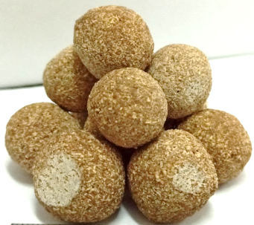
appearance | structure
Fig. 2. Granulated magnesia aggregate.
The aggregate is obtained from a molding mass containing a magnesia binder, wood particles and a pore-forming agent.
3 Results and Discussion
The insertion of an ash microsphere into the magnesia mixture is accompanied by a decrease in the density of the composite material (table 1). The strength of the compositions depends on the fraction of the ash microsphere and decreases as the structure is saturated with hollow particles, which is obvious for the systems under study. The properties of the compositions are largely determined by the composition of the mixed binder. The content of the ash microsphere should be limited to 20%, as an increase in the proportion of porous particles causes a shortage of binder for binding the microsphere.
Table 1. Influence of microspheres on the properties of magnesia compositions.
Content of technogenic filler in the binder, % | Content of the microsphere,  % | Average density,  kg/m³ | Tensile strength at compression, MPa
0 | 0 | 1879 | 67
0 | 5 | 1750 | 60
0 | 10 | 1578 | 48
0 | 15 | 1616 | 45
0 | 20 | 1441 | 37
0 | 30 | 1384 | 32
30 | 10 | 1768 | 53
50 | 10 | 1796 | 49
50 | 5 | 1956 | 55
The use of mixed binders is advisable with a limited content of the porous component in order to avoid a sharp deterioration in the technological properties of the molding mass.
The nature of the influence of the microsphere concentration does not differ in principle for binders of different material composition (Fig. 3). High strength of compositions with microspheres is due to the effect of magnesium chloride on the surface of aluminum silicate particles.
The insignificant solubility of the microspheres material in the medium of the chloride-magnesia matrix initiates the appearance of fibrous forms of aluminosilicate new formations on the surface, which contribute to increased adhesion to the matrix of the binder stone.

Fig. 3. Influence of the ash microsphere content on the composition properties.
An effective porous technogenic aggregate is expanded polystyrene granules formed during the destruction of used containers. Expanded polystyrene granules are one of the lightest concrete aggregates.
Expanded polystyrene granules are inserted to reduce the consumption of the binder, as well as to improve the thermal insulation characteristics. Practical implementation of the developments will lessen the cost of production and reduce environmental tensions in the regions.
To obtain a homogeneous technological molding mixture, a mobile mass of binder is required, enveloping light polystyrene granules. For this purpose, it is advisable to porize the binder paste, the density of which significantly exceeds the similar characteristic of expanded polystyrene. The uniformity of distribution of expanded polystyrene granules in the structure of compositions increases when using foam mass. To form stable magnesia foam mass, it is necessary to introduce 2.5 – 3.0 % of the foaming agent.
Masses with different amounts of expanded polystyrene granules were studied (table 2). Preparation of the molding mixture involves: at the first stage, foam mass is obtained in a mixer for 2.5 minutes, at the second stage, expanded polystyrene granules are added and mixed together until a homogeneous state is obtained. The porizing components complete each other, creating a composite with a density of 300 kg/m³ or less.
To make the molding mass, a solution of magnesium chloride with a density of 1230 kg/m³ was poured into the mixing container, a protein foaming agent was added, and then the mixed binder was filled in. The resulting suspension was foamed in a blender type mixer.
The insertion of expanded polystyrene granules significantly reduces the density and strength of magnesia samples.
Table 2. Influence of expanded polystyrene on the properties of the foam-magnesium composition.
Amount of expanded polystyrene, % | Density, kg/m³ | Strength at the age of 7 days, MPa
0 | 520 | 5.8
4 | 330 | 3.4
7 | 200 | 1.2
10 | 150 | 0.8
These compositions are appropriate as a heat-insulating part (central) in three-layer composite products, which must have a low density, heat-protective qualities and adhesion of foam mass with granules.
Expanded polystyrene granules together with foam mass can provide an effective combined structure with a low density.
For the formation of low-density magnesia compositions, a combination of porization methods is proposed (table 3).
Table 3. Comparative characteristics of magnesia compositions.
Method for forming a porous structure | Density,  kg/m³ | Thermal conductivity, W/(m∙⁰С) | Compressive  strength, MPa
Foam formation | 525 | 0.07 | 4.3
Gas formation | 650 | 0.09 | 4.6
Foam formation + gas formation | 390 | 0.05 | 2.2
Foam formation + microsphere | 435 | 0.08 | 3.6
Foam formation +  expanded polystyrene granules | 285 | 0.05 | 1.0
Foam formation +  swelling granules on the liquid glass basis | 350 | 0.05 | 3.2
Foam formation + gas formation + expanded polystyrene granules | 220 | 0.04 | 0.8
When hydrogen peroxide is added to foam mass in the composition of the formed pores of different types: large cells and small gas pores of the foam, located in partitions between large are formed (Fig. 4). The possibility is shown of additional pore foam mass and the combined framework by 5 – 20 % porous granules. When inserting expanded polystyrene granules into the foam mass, the density decreases by 1.8 times. To create a cellular-granular structure, swelling granules of liquid glass were inserted. It is possible to reduce the density of the compositions by 33 %.
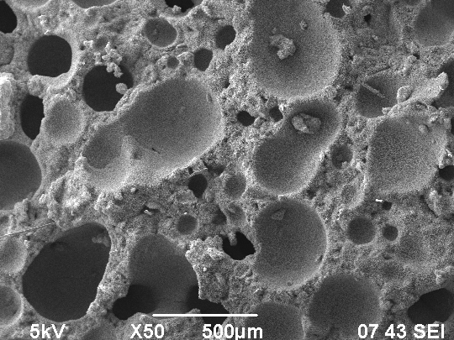  1  2 | 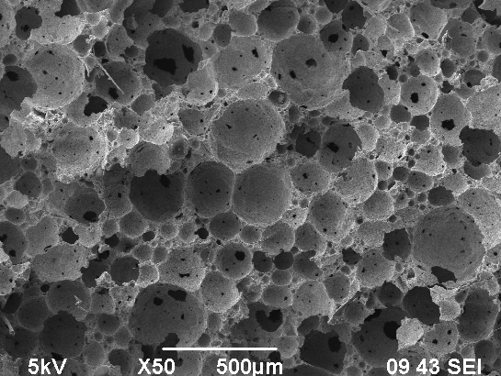
1 – gas formation; 2 – foam formation + gas formation + 15 % microspheres
Fig. 4. Microstructure of magnesium compositions with different porization.
Compositions based on a mixed magnesia binder and integral aggregate “expanded polystyrene – wood particles – ash microsphere” are proposed. Optimization of the particle ratio makes it possible to obtain a combined structure that is maximally “packed” with different pores. The compositions are characterized by a density of 350 – 650 kg/m³ and a compressive strength of 1–7 MPa.
A rational method for preparing the molding mass is determined, which provides for the initial contact of the binder with a solution of magnesium chloride; then the addition of step-by-step fillers. The method will provide increased strength, uniform distribution of components. As a fibrous component, substandard wool and waste from the production of mineral wool were used. Technogenic fibre (2%) provide hardening of interporous partitions of aerated structure.
To obtain porous compositions, a granulated magnesia aggregate was used, which was inserted into the molding foam mass at a ratio of “binder: filler” – 30:70 %. The resulting magnesia concrete is characterized by a density of 540 kg/m³ and a compressive strength of 4.1 MPa (Fig. 5).
1  2 | 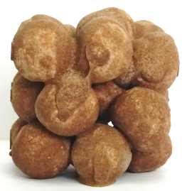
1 – porous structure; 2 – large-pore structure
Fig. 5. Structure of compositions with porous magnesia aggregate.
Granulated magnesia aggregate can be used in coarse-pored concrete with a density of 510 kg/m³ and a strength of 2.2 MPa.
4 Conclusion
The possibility of creating porous compositions based on mixed magnesia binders and aggregates of different composition and structure is proved. The expediency of combining the mechanisms of foam and gas formation for the formation of a cellular structure is shown. The conditions and advantages of combined structures due to the combination of cellular, granular and fibrous porosity are determined.
5 Acknowledgements
This research is funded by the Science Committee of the Ministry of Education and Science of the Republic of Kazakhstan (Grant No. AP08856219).

References
- Chen L., Wang L., Daniel C.W., Tsang V., Chi M., Poon S.: Efficacy of green alternatives and carbon dioxide curing in reactive magnesia cement-bonded particleboards. Journal of Cleaner Production 258, 120997 (2020).
- Xu B., Ma H., Hu C.: Influence of curing regimes on mechanical properties of magnesium oxychloride cement-based composites. Construction and Building Materials 102, 613 – 619 (2016).
- Ba M., Xue T., He Z., Wang H., Liu J.: Carbonation of magnesium oxysulfate cement and its influence on mechanical performance. Construction and Building Materials. 223, 1030 −1037 (2019).
- Zhu H.,Yu H., Ma H.,Yang S.: Uniaxial compressive stress-strain curves of magnesium oxysulfate cement concrete .Construction and Building Materials. 232, No 117244 (2020).
- Ruan S., Unluer C.: Influence of supplementary cementitious materials on the performance and environmental impacts of reactive magnesia cement concrete. Journal of Cleaner Production 159, 62 − 73(2017).
- Kumar S., Sonat C., Yang E.-H., Unluer C.: Performance of reactive magnesia cement formulations containing fly ash and ground granulated blast-furnace slag. Construction and Building Materials 232, No 117275 (2020).
- Miryuk О.А.: Properties of magnesium composite materials based on technogenic raw materials. ARPN Journal of Engineering and Applied Sciences. 2(13), 545 −558 (2018).
- Mitina N.A., Revva I.B., Ditts A.A., Simonov D.V.: Waterproof Magnesia Binder for Composite. Materials. Key Engineering Materials 712, 182 −187 (2016).
- Miryuk О.А.: Porous magnesia compositions of a combined structure. IOP Conference Series: Materials Science and Engineering. Modern Building Materials 365, 032052 (2018).
- Xiangming Z., Zongjin L.: Light-weight wood-magnesium oxychloride cement composite building products made by extrusion. Construction and Building Materials 27, 382 – 389 (2012).

