Technology of 3-D printing of fiber reinforced mixtures
Klyuev S.V.¹, Candidate of Engineering Sciences, Associate Professor, Klyuev A.V.¹, Candidate of Engineering Sciences, Associate Professor,
¹ Belgorod State Technological University named after V.G. Shukhov, Belgorod, Russia
Klyuyev@yandex.ru
Abstract. Due to the introduction of reinforcing fibers into concrete, it is possible to overcome one of the main disadvantages of concrete-low tensile and bending strength. This is due to the fact that the reinforcing fibers take on a tensile stress, resulting in increased tensile resistance (in percentage terms, this is about 250%). In addition, reinforcing fibers contribute to the uniform distribution of moisture in the concrete due to which internal loads are reduced, crack resistance is approximately doubled and the impact strength of the concrete is 12 times increased. In addition, the deformability, frost resistance, heat resistance, water resistance and corrosion resistance of concrete structures are significantly increased. What makes fibroblast ideal material for use in 3D printing.
Keywords: silica fume, additive, 3-D technology, concrete, fiber.
Introduction
One of the important motives for the use of additive technologies in the construction industry is also the safety of industry workers, especially in extreme conditions. When construction is carried out in harsh conditions, the degree of complexity and risks for the worker inevitably increases, which negatively affects both the quality of construction and human safety [1-7]…….

Methods and materials
When designing the composition of fine-grained concrete for 3D printing, it is necessary to take into account the consistency of the concrete mixture to obtain the required workability. The technological scheme of production of a concrete mix begins with reception of composite binders and includes a set of operations as a result of which receive the required product.
The technology of layering the mixture is realized through extrusion printing technique, which produces three-dimensional objects from a computer model, as in a typical rapid prototype process. Detailed models can be obtained from computed tomography, magnetic resonance imaging, or model data created from three-dimensional object digitization systems and used in this technique. In the surfacing simulation method, fiber concrete is extruded and deposited as a semi-molten polymer onto a platform in a layer-by-layer cycle………
A comparative analysis of the technical and physico-mechanical characteristics of the fiber types considered is given in table 1.
Table 1. Technical and physico-mechanical characteristics of various types of fibers
 | Characteristics and values of fiber characteristics indicators
Types of fiber | Strength on  Stretching (MPa) | Diameter  fibers | Length  fibers (mm) | Module  of elasticity GPa | Coefficient  elongations (%) | Temperature  melting (⁰С) | Density, (g/cm3) | Resistance to  corrosion  and alkalis
Metal wire  made of carbon steel | 600-1500 | 0,5-1,2 mm | 30-50 | 190 | 3-4 | 1550 | 7,8 | low
Polypropylene | 150-600 | 10-25 mkm | 6-18 | 35 | 20-150 | 160 | 0,91 | high
Fiberglass | 1500-3500 | 13-15 mkm | 4,5-18 | 75 | 4,5 | 860 | 2,6 | average
The analysis of technical and physico-mechanical characteristics of different types of fiber, given in table 1 allows us to conclude that each type of fiber has certain advantages.

Results and discussions

The reason for the reduced travel speed and fill speed was mainly to avoid problems such as skipping steps during printing, which occurs in most cases due to high speeds during printing. The fill type was chosen square grid and the density was set to 70%, filling so that the printed parts were solid…….
In the last few years, various methods of 3D concrete printing have been used based on two technologies, namely extrusion-based and powder-based. Consider extrusion technology………..
Once the extruded formwork is complete, the concrete is then poured by hand to a height of 13 cm and an hour later a second portion is poured on top of the first portion. Each batch of concrete is laid with a delay of one hour, in order to control the lateral pressure of the concrete, allowing it to partially harden. and harden. The shape of the concrete wall made by the machine is shown in figure 3.

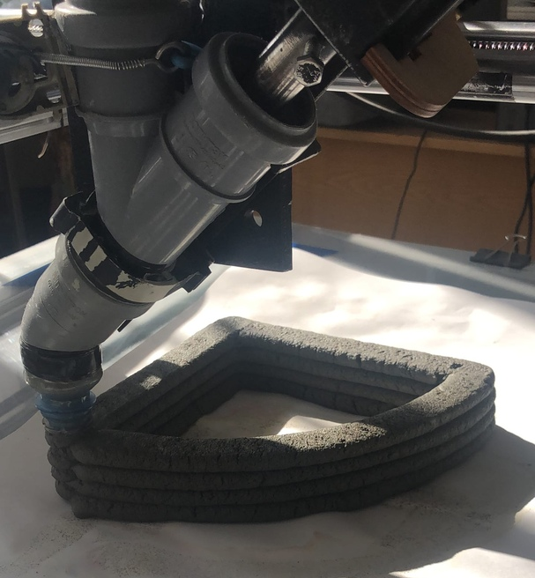
Fig. 3. Concrete wall shape, manufactured with contour machining machine, with reinforced screeds, custom made, manually inserted between the layers

The following disadvantages of the technology of the analyzed printing technology are distinguished:
- time to maintain dimensional accuracy, makes the printing process quite slow, so the prospects for the intended industrial application are uncertain;
- using a second material to support overhangs reduces the efficiency and flexibility of the process while increasing the cost of the material;
- dimensions and possibilities in terms of shaping are limited by the size of the printed frame.

Conclusion

It should be noted that 3D printing is mostly done for fast operations or prototyping, which means low fill volume. A typical fill percentage is about 20% for 3D printing depending on the actual use of the 3D printed part. If the part is to be used for construction, the fill percentage increases, if the part is printed as a prototype to test the design, sometimes a lower fill percentage is used, such as 10%. Printing a part with 100% filling adversely affects the purpose of 3D printing using material extrusion and significantly increases the printing time.

References
- Slavcheva, G.S., Artamonova, O.V.: Rheological behavior of 3D printable cement paste: criterial evaluation. Magazine of Civil Engineering 84(8), 97–108 (2018).
- Fediuk, R.S., Lesovik, V.S., Svintsov, A.P., Mochalov, A.V., Kulichkov, S.V., Stoyushko, N.Y., Gladkova, N.A., Timokhin, R.A.: Self-compacting concrete using pretreatmented rice husk ash. Magazine of Civil Engineering 79(3), 66–76. (2018).
- Fediuk, R., Pak, A., Kuzmin, D.: Fine-Grained Concrete of Composite Binder. IOP Conference Series: Materials Science and Engineering 262(1), 012025 (2017).
- Denisova, Yu.V.: Additive technology in construction. Construction Materials and Products 1(3), 33–42. (2018).
- Kozhukhova, N.I., Strokova, V.V., Kozhukhova, M.I., Zhernovsky, I.V.: structure formation in alkali activated aluminosilicate binding systems using natural raw materials with different crystallinity degree. Construction Materials and Products 1(4), 38–43. (2018).
- Klyuev, S.V., Klyuev, A.V., Khezhev, T.A., Pucharenko, Yu.V.: Technogenic sands as effective filler for fine-grained fibre concrete. Journal of Physics: Conference Series 1118, 012020 (2018).
- Klyuev, S.V., Klyuev, A.V., Vatin, N.I.: Fine-grained concrete with combined reinforcement by different types of fibers. MATEC Web of Conferences 245, 03006 (2018).
- Klyuev, S.V., Klyuev, A.V., Khezhev, T.A., Pucharenko, Yu.V. High-Strength Fine-Grained Fiber Concrete with Combined Reinforcement by Fiber. Journal of Engineering and Applied Sciences 13(8 SI), 6407–6412 (2018)………….

